Dr Martin Graham PhD, CEO Empire Discovery Institute
Email: martin_graham@URMC.rochester.edu
Mobile: (484) 880-6145
Empire Discovery Institute (EDI)
“Transforming Discoveries into Medicine”

Empire Discovery Institute (EDI)
“Transforming Discoveries into Medicine”

Dr Martin Graham PhD, CEO Empire Discovery Institute.
Email: martin_graham@URMC.rochester.edu; Mobile: (484) 880-6145

Executive Summary
EDI represents a transformative approach to drug discovery & development. It sources innovative, commercially attractive drug discovery programs from its three collaborating academic centers (the University of Rochester [UR], University at Buffalo [UB] and Roswell Park Cancer Institute [RPCI]) to address critical, unmet needs for patients. Our goal is to create highly attractive, novel and differentiated drug assets, that have been optimized and de-risked through the early pre-clinical and clinical/IND (first in human) stages of development, that will attract significant interest and investment from external partners. This is turn will lead to opportunities for new company creation and/or pharma in-licensing deals.
This new enterprise has been established with an initial grant and investment commitment of $35.4M from the New York State Life Science Initiative. Through a rigorous selection process, attractive drug targets are identified, prototype lead-compounds are created, and prospective drug candidates are optimized and accelerated through a systematic process, to an early “proof-of-concept”. EDI is focused on value creation. Through its selective deployment of capital, combined with deep pharmaceutical industry expertise, the most promising programs are progressed to pre-defined go/no-go decision points. Selection criteria and data-driven metrics are used throughout each step of the process to ensure that EDI’s resources are focused on the most promising and viable programs. This highly analytical, disciplined and systematic approach to drug discovery and development ensures that EDI’s financial, scientific and technical resources are deployed in the most appropriate way to create maximum impact and value. EDI is an evergreen, not-for-profit, pharmaceutical translator. It seeks to re-invest capital generated from these activities back into the discovery and development engine it has created to advance the next generation of new medicines. EDI has been established for the benefit of our partner institutions, as well as our valued investors, our partners in the pharmaceutical industry and most importantly our patients. EDI will also serve as an important catalyst for the economic development of the region and help facilitate the growth of a vibrant life science industry in NYS.
Situation Analysis
A “valley of death” exists between basic research activities occurring in academia and the drug development and commercialization efforts of the pharmaceutical industry. A recent survey by the Deerfield Institute reveals that approximately 95% of the 2.1 million active patents in the US fail to be licensed or commercialized. Over the past 20 years this has been estimated to represent more than $5 trillion in research expenditure, the fruits of which have remained largely unlicensed and un-commercialized. The pharmaceutical industry, on the other hand, is currently facing a different set of issues. Under increasing pressure to reduce their internal R&D expenditure, while being driven by competitive forces to develop novel and highly differentiated drug products that can attract premium pricing, drug companies are increasingly relying on external sources of innovation to fill their pipelines. Unfortunately, this thirst for new sources of innovation is not being adequately addressed due to disconnects and misalignment of interests that often exist between academia and industry. This so-called “valley of death” can be attributed two important elements that are frequently missing; 1) adequate levels of funding for translational drug discovery and 2) access to pharmaceutical industry expertise and know-how to select, advance and de-risk promising drug candidates to a point that is attractive to a potential pharma partner. The creation of EDI addresses these two problems.
Our Approach
EDI is organized as a 501(c)(3) not-for-profit corporation. An Affiliation Agreement has been established between EDI and the University of Rochester (UR), University at Buffalo (UB) and Roswell Park Cancer Institute (RPCI) to openly collaborate on the identification and advancement of early stage drug discovery programs. EDI’s Board of Directors comprises two senior leaders from each institution. EDI’s Secretary, Treasurer, Legal Counsel, as well as independent board observers routinely participate in EDI’s quarterly board meetings. EDI’s senior leadership (CEO), together with the board of directors are in the process of establishing an expert Scientific Advisory Board (SAB) with deep pharmaceutical industry experience to help guide these promising assets to a successful value inflection and exit.
The experience and skill-set of the SAB is an essential component and driver of EDI’s strategy. The SAB, comprising of pharmaceutical industry veterans with deep experience in the discovery, development, registration and commercialization of small molecule and biologic drugs, will be instrumental in establishing and executing EDI’s strategic vision.
To be successful, EDI believes it is essential to understand and integrate multiple “key factors” into its program evaluation and selection criteria. These factors include:
a) A clear understanding of the un-met needs in a given disease or therapeutic area.
b) The strategic and commercial interests of potential pharmaceutical industry licensees.
c) Competitive intelligence, especially the nature and stage of development of other programs in a similar space.
d) The market size opportunity and projected revenue streams within key global markets including the US, EU, Japan/Asia.
e) Scientific/Technical feasibility and the likelihood of success.
f) A strong IP position or the ability to develop a strong IP position through freedom to operate analyses and the generation of defendable composition of matter/methods of use patents.
g) The opportunity to demonstrate early “proof-of-concept”, particularly through the application of quantitative measures of success (i.e. biomarker driven outcomes).
h) The opportunity to establish a clear clinical and regulatory path to product approval.
i) Enthusiastic, committed and coach-able scientific founders who are willing to become engaged with EDI’s advisory board, external innovation partners, investors and prospective pharma partners/licensees in a collaborative and entrepreneurial venture.
EDI’s Scientific Advisory Board will use the above framework to make its selection decisions from an integrated list of Intellectual Property (IP), comprising of over 200 potential research projects and patents, from the three participating institutions.
Selected programs will be provided access to capital and specific scientific/technical expertise from EDI’s SAB to advance a given program to defined decision (go/no-go) milestones. This process will involve the development of a specific work-plan with clear objectives, together with an associated budget to support the agreed-upon development activities.
It is envisioned that EDI’s small molecule drug development programs will require comprehensive medicinal chemistry support from the SAB, in conjunction with external chemistry, assay development/validation and pharmacology, biology, formulation, toxicology and regulatory affairs support. This will be accomplished through the engagement of consultants and external, (fee-for-service) vendors with high-throughput screening capabilities, advanced computational drug design capabilities and access to diverse compound libraries to serve as the starting point for the development and optimization of a new compound series. EDI has identified several potential strategic partners for these specialized pharmaceutical development services. EDI’s SAB will also engage experts in the discovery and development of biologic-based therapeutics, as well as gene-therapy and cell-based approaches as these opportunities are identified.
It is anticipated that EDI will advance multiple programs within its selected areas of focus, establishing specific franchises in cancer, neurological diseases, inflammatory and immune disorders, cardio-metabolic diseases, ophthalmology and rare/orphan indications (one of the fastest growth areas in pharma). EDI also plans on establishing a “global health initiative” to advance the substantial number of infectious disease and vaccine based assets in the IP portfolio.
The application of EDI’s “market-back, science-forward” approach (Figure 1), is intended to rapidly advance and de-risk the most promising programs in its pipeline, and create value through the early demonstration of “proof-concept”. Data-driven decision making will be applied to objectively prioritize, resource and advance the most promising opportunities in EDI’s portfolio for out-licensing or New-Co creation.
Opportunities
EDI has been granted an unprecedented opportunity by the New York State Life Science Initiative to create a vibrant and successful new drug discovery and development ecosystem across the three member institutions. This initiative has potentially significant financial benefits for all three of the member institutions as well as significant economic development and job creation implications for the region and State.
It is imperative that EDI quickly becomes a self-sustaining “ever-green” venture. For this reason the initial selection decisions will be biased towards the more mature programs in the portfolio to facilitate early wins and returns. Revenues from successful exits will be disbursed back to the member institutes and EDI. This will give EDI the ability to re-invest back into its system to advance the next generation of therapeutics, thereby creating a “virtuous cycle”. It will be important therefore that EDI’s capital be deployed in the most efficient way possible and that any investment agreements with a strategic partner or venture capital firms will retain the maximum value for the benefit of the three member institutes and for the sustainability of EDI.
To satisfy its financial commitments and to obtain at least $12-15M in matching funds in addition to the awarded $34.5M over 5-years, EDI would like to attract and establish diverse and non-dilutive sources of funding from philanthropic donations, grants and disease foundations. EDI will also seek investment from strategic pharma partners who will in return be granted first rights of refusal to selected programs in which they invest. EDI is also open to venture funding and is currently in discussions on agreement terms with two venture capital funds.
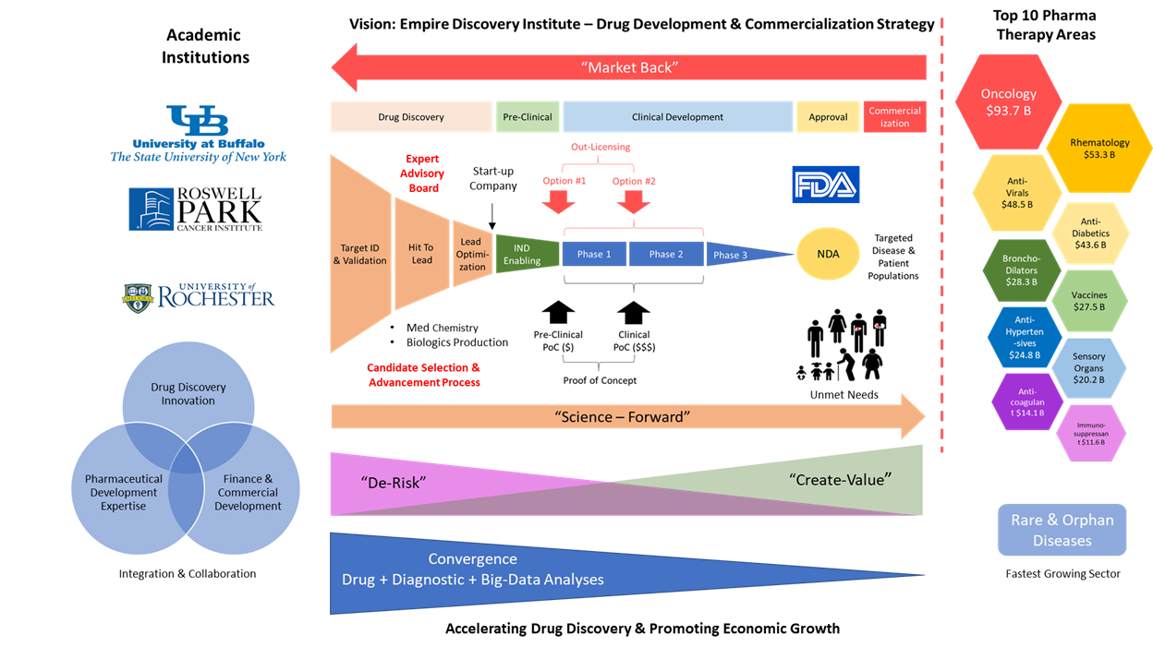

Figure 1. Empire Discovery Institute: “Market-Back Science-Forward “Strategy

Deerfield Institute Report. Key insights into technology transfer offices

